Lesson 5 Homework  FRONT PAGE | LT 3.1, 3.2, 3.3 | 3, 5, 6, 8, 10-15, 19 (FRONT PAGE)  1, 5-7, 17, 21, 31 (BACK PAGE)

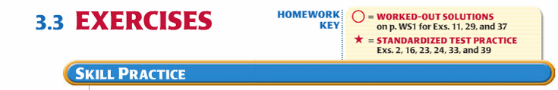
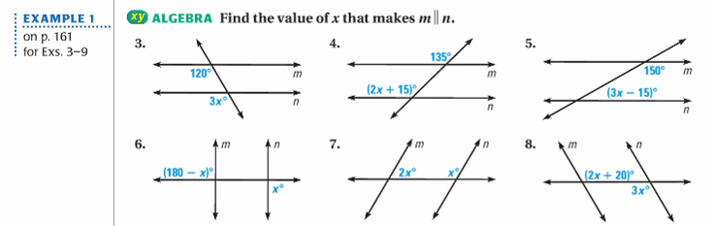
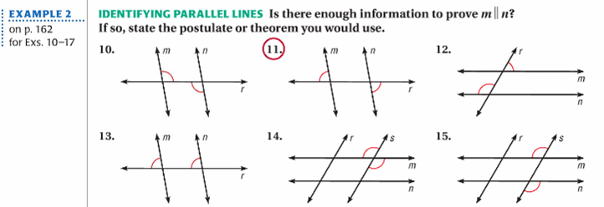
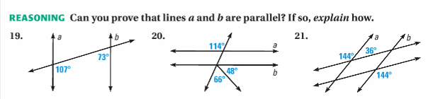

Lesson 5 Homework  BACK PAGE | LT 3.1, 3.2, 3.3 | 3, 5, 6, 8, 10-15, 19 (FRONT PAGE)  1, 5-7, 17, 21, 31 (BACK PAGE)

